# Visualizations

## Trend 1

* Seasonal factors affect usage a lot and they affect casual users much more than member users, in cold seasons, casual users ride much less compared to warmer seasons.

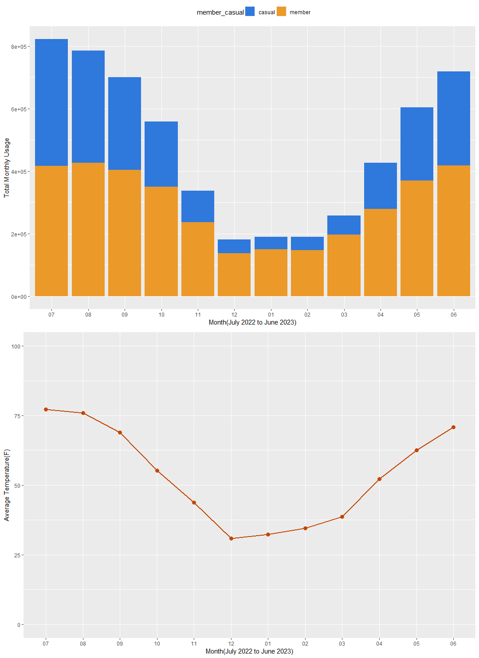

* Linear regression between daily usage and daily average temperature

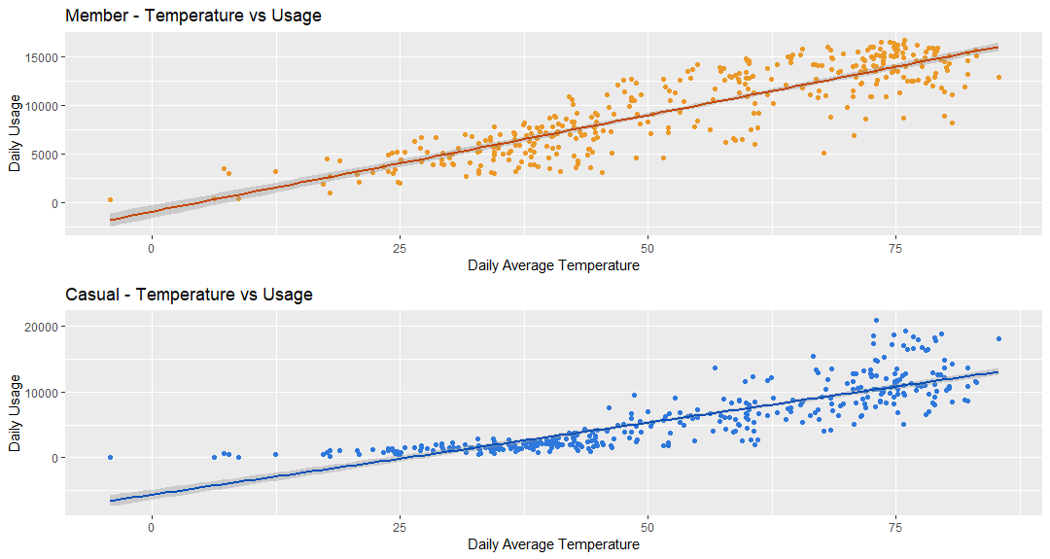

## Trend 2

* Casual users & member users have varying average usage distribution in a day.

## Trend 3

All seasons - huge discrepancy on rides distribution throughout the week

- member users take rides more often on weekdays, and less on weekends

* Only on weekends their distribution resemble, further verifying the insight that member users focus more on commutation while casual users focus less

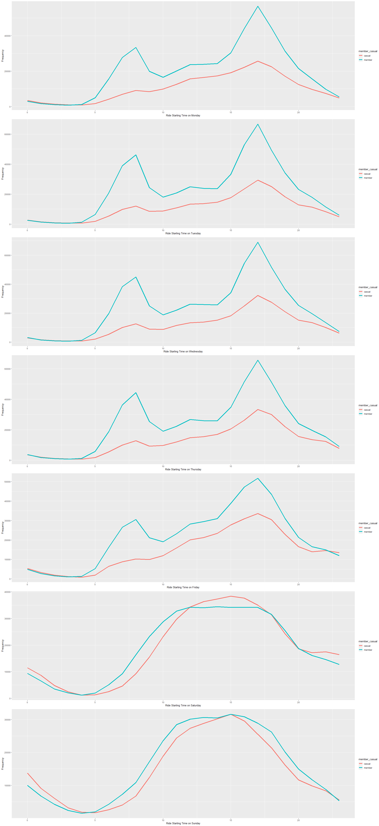

## Relationship 1

* There are more member users usage than casual users usage

## Relationship 2

* member has slightly shorter & less variable ride duration on average compared to casual usage

